

CSE 3001

Software Engineering

LAB Assessment - 4

**NAME**: Vibhu Kumar Singh

**REG. NO**: 19BCE0215

**TEACHER**: Ushus Elizebeth Zachariah



PROJECT TOPIC:

Smart Parking System

(19BCE0215)

Activity Diagram:

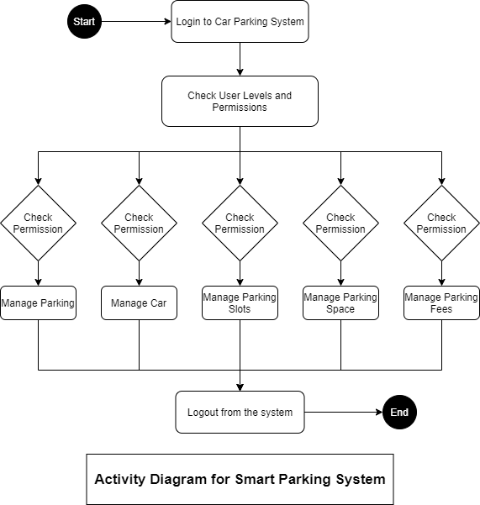

(made on draw.io)

Activity Diagram for Login Page:

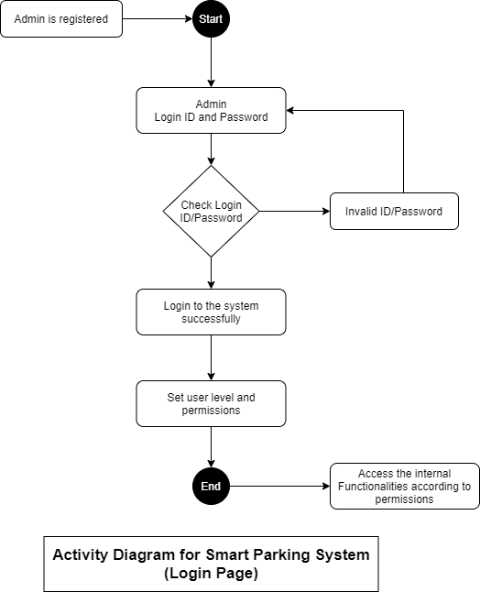

(made on draw.io)

**Q3) Group project updates :-**

**TOPIC: College Admission Management System**

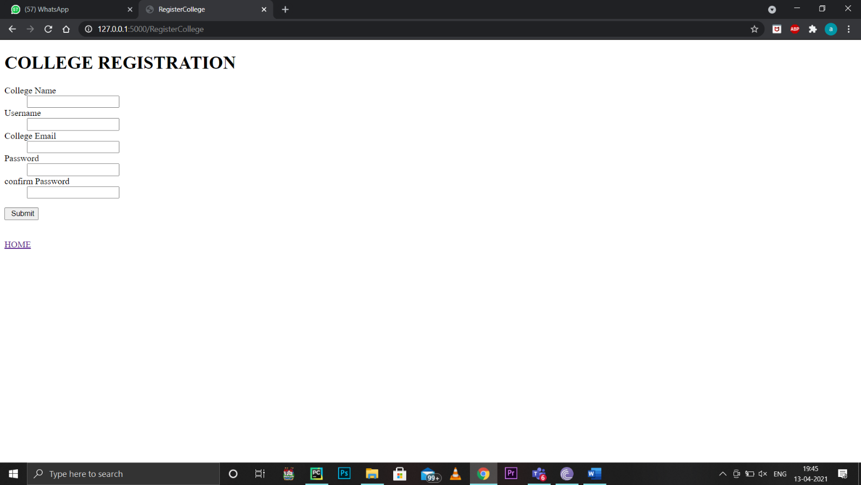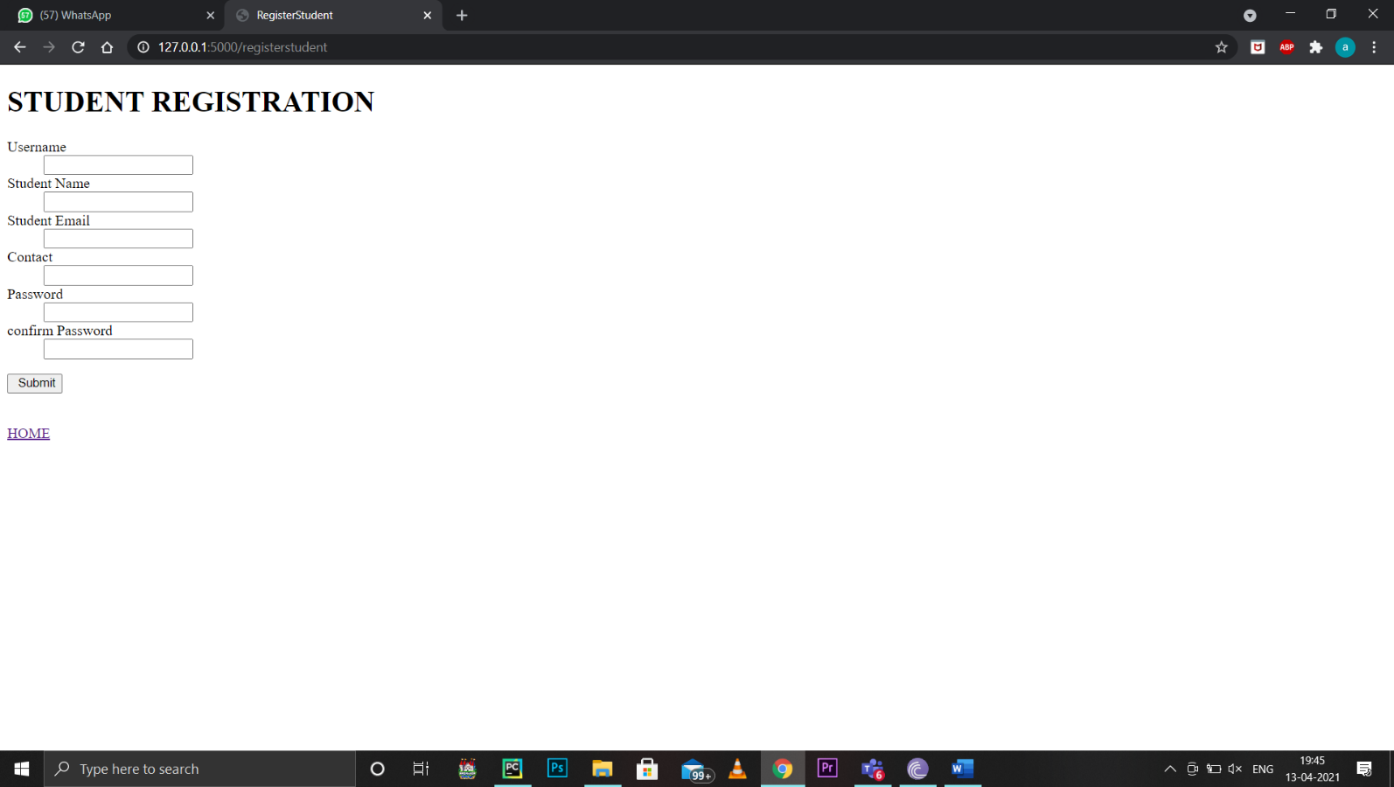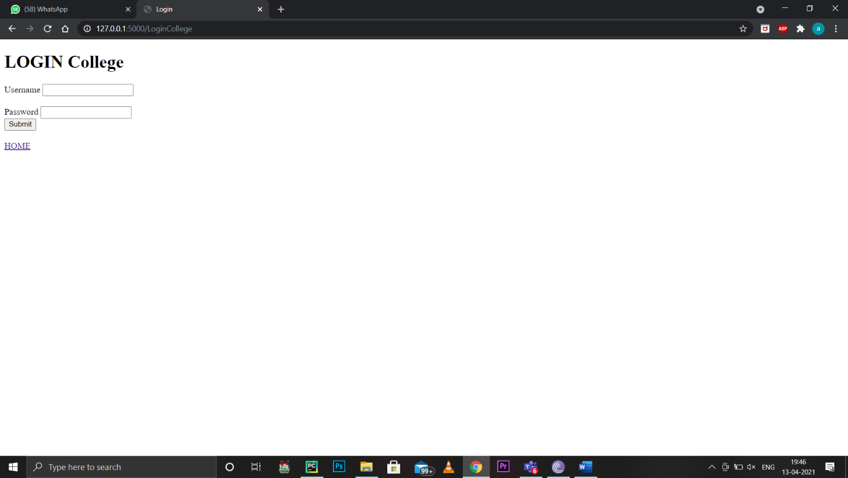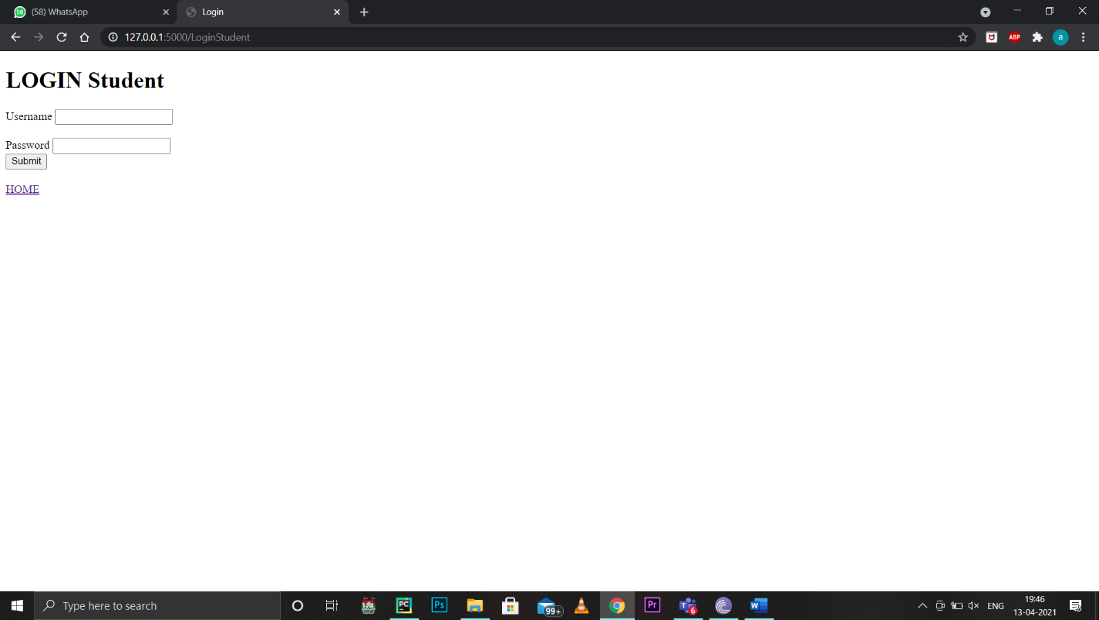

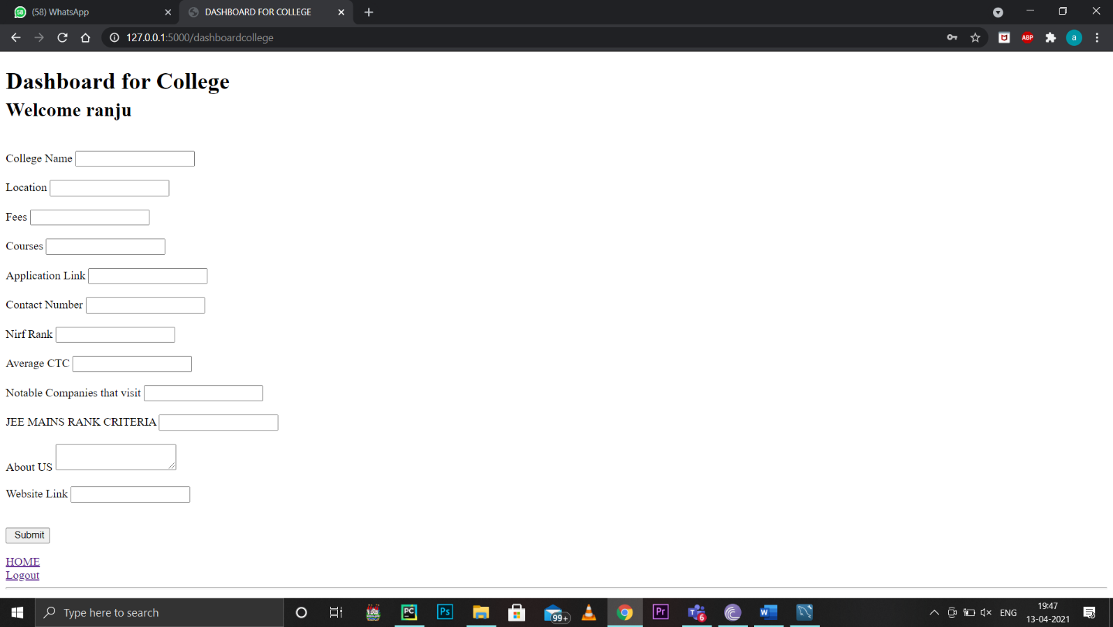

**After submitting details:** 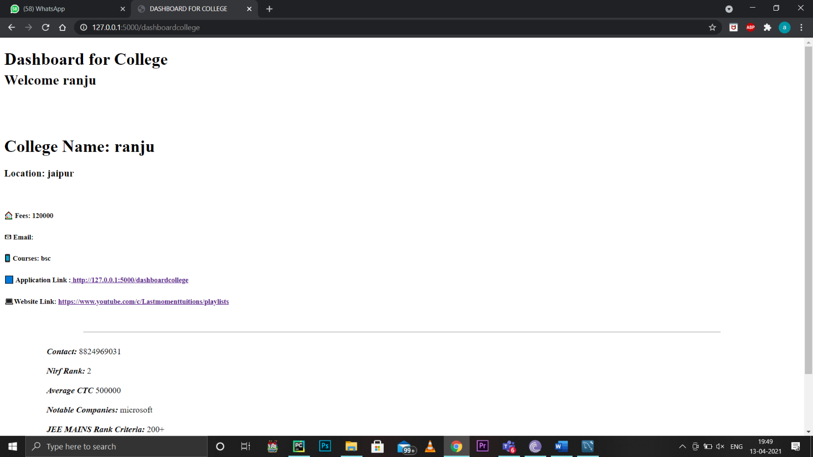

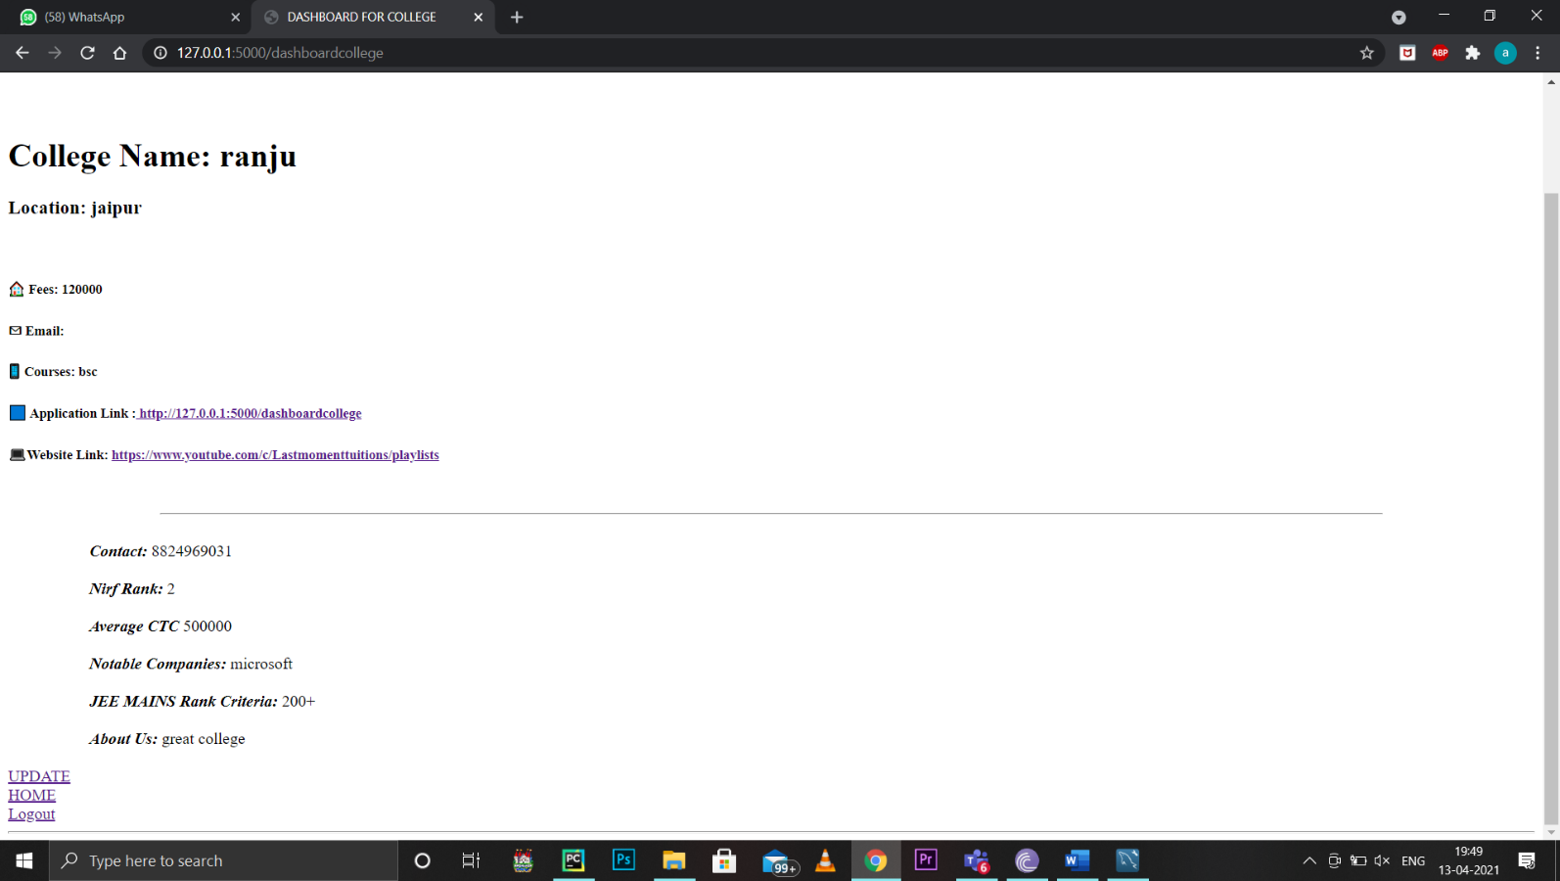

So far, we have made this…the college registration interface…CSS and JS are still to be added. Styling will done later. As of now the project is connected and well integrated with backend server and replies to the queries, we can register as a college and as a student. Submit college details, the work is expected to be finished between 15-20 days.

**Working 🡪**

We will use flask framework with MySQL database for our project, this is a multi interface project where two types of users can login: a) the student who wants to check and sort college as per will and b) colleges who can advertise themselves this multi interface is possible with session variables. We have connected the database from frontend using flask_mysqldb library. Here we have created mysql variable instance which connects and holds the information when the user gives it. In addition to it we have used WTforms for taking user input. For saving the data cursors will be used which will act as a mysql variable which will hold the query on a temporary basis and after execution will release the data by the use of cur.close() method. Further more Get and post methods will be used for taking input from user via user interface. Templating is used which connects the user interface with backend.

**ER Diagram**

